7 Operational Feasibility
Operational feasibility is moderate to high because the proposed system follows recognizable university responsibilities. The workflow becomes difficult only if the application requires duplicate data entry, unclear ownership, or too many approval steps. The prototype should prove that each role can complete its part without seeing or changing unrelated information.

7. 1 Proposed Operating Workflow
1. A department representative registers an asset or updates an approved record.
2. An asset custodian verifies condition, location, custody, and whether the item can be published.
3. A requester searches available records or submits a structured need.
4. The system returns rule-based results and optional AI-ranked recommendations with explanations.
5. Authorized staff review the request, confirm availability, and approve or reject the proposed release and transfer.
6. The system records collection or delivery, custody change, new location, and receipt confirmation.
7. Maintenance and sustainability events update the life cycle history and reporting measures.

7. 2 Adoption Conditions
Table 7 Operational Adoption Conditions
Condition | Why It Matters
Clear ownership | Users need to know who may publish, approve, transfer, and close records
Low entry burden | Long forms will produce incomplete or outdated records
Visible status | Departments need to know whether a request is waiting, approved, rejected, or completed
Reliable search | Users will abandon the exchange if relevant assets are hard to find
Human accountability | AI suggestions cannot replace approval or safety review
Training and help | Different roles will use the system at different frequencies
Support path | Incorrect records and access problems need an owner

7. 3 Change Management
The pilot should begin with a small number of categories and departments rather than attempting university-wide adoption. A narrow pilot makes it possible to align category names, test approval responsibilities, observe where users stop, and correct the workflow before more data accumulates. The team should collect feedback after asset registration, request submission, recommendation review, and transfer confirmation. The most useful operational metrics are task completion, time to complete, error rate, support requests, abandoned requests, and the reasons users override recommendations.

8 Schedule Feasibility
The project schedule remains feasible only if scope is reduced early and milestone dependencies are controlled. Phase 2 is due on 21 September 2026. Requirements are due on 5 October, design on 26 October, draft implementation on 16 November, and testing and final delivery on 23 November. The final period is compressed because testing and final delivery share the same deadline, so feature development must stop early enough to protect correction and documentation time.

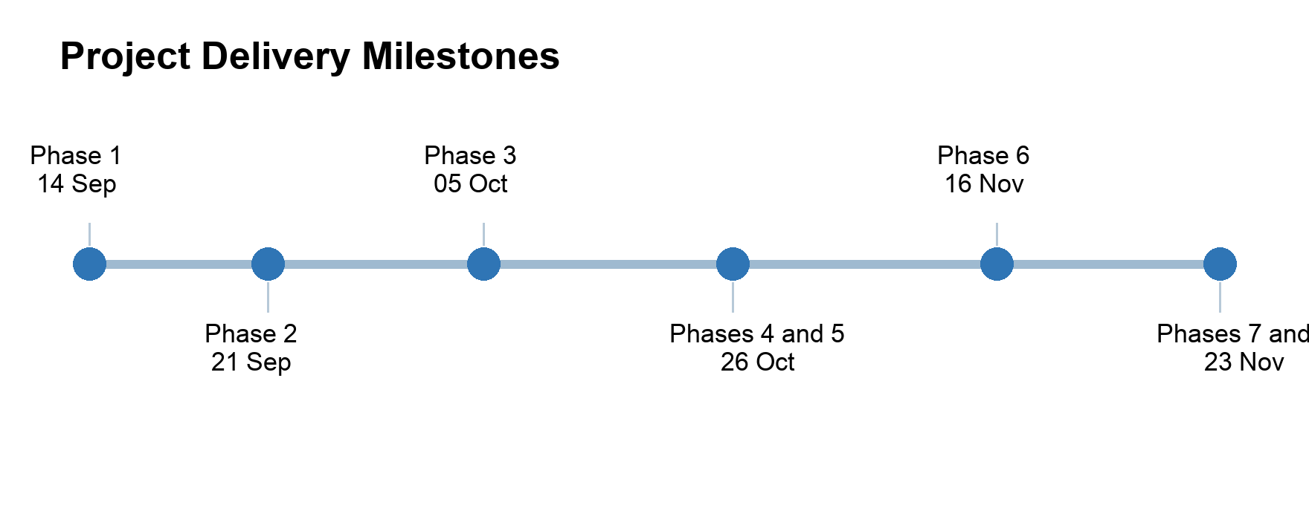
Figure 1 Project delivery milestones

8. 1 Development Priorities and Dependencies
Development should begin with a stable data model and clearly defined user roles because the system’s main functions depend on consistent asset and request information. After these the team can start to develop search, AI-supported matching, approval, and transfer. The required data and role responsibilities should be defined during the requirements phase and confirmed during the design phase before optional features are developed. Integration work should begin as soon as the data structures and communication rules are finalized so that technical problems can be identified and corrected before final testing. Priority should remain on completing and testing the core workflow before adding secondary features.

8. 2 Scope Tiers
Table 8 Scope Priorities
Tier | Functions | Schedule Decision
Essential | Authentication, roles, departments, asset registration, publication, search, request, approval, transfer confirmation, maintenance history, audit log | Must work end to end before optional features
Essential - AI | One classification or semantic matching service, confidence, explanation, user review, evaluation set, deterministic fallback | Implement one function well rather than several untested functions
Desirable extension | Second AI function, basic assistant, generated narrative report, notification improvement | Add only after the essential workflow and tests pass
Future enhancement | Image recognition, predictive demand, full university integrations, advanced carbon model, autonomous workflow actions | Exclude from the semester minimum scope

8. 3 Two Person Work Allocation
One team member can lead the user interface, application workflow, and baseline search while the other leads the database, AI adapter, and deployment. Both members should review the requirements, data model, integration, tests, and documentation. The team should not divide the project into isolated halves that meet only at the end.

